Architecture Views

Revision History
Rev | Date | Revision History
00 | 2025.04.16 | First Issued.

Contents
1. Introduction 4
2. Purpose and Scope 4
3. System Architecture Overview 4
4. Security Architecture Views 4
4.1 Hardware Architecture 4
4.2 Software Architecture 5
4.3 Network Architecture 5
4.4 Data Flow Architecture 6
5. Security Mechanisms and Controls 7
6. Documentation 8

- Introduction
This document provides a structured approach for documenting architecture views in compliance with the FDA's guidance on cybersecurity in medical devices. Architecture views help define the security design and structure of a medical device system, ensuring its resilience against cyber threats.
- Purpose and Scope
Describe the purpose of architecture views in the context of medical device security. Define the scope of architectural representations, including hardware, software, network, and data flow considerations.
- System Architecture Overview
Provide a high-level overview of the medical device system, including its key components, connectivity, and data flows. Include diagrams where applicable.
- Security Architecture Views
The following architecture views should be documented to illustrate the security design of the medical device:

4.1 Hardware Architecture
Describe the hardware components of the medical device, including:
- Processing units and memory
- Hardware security modules (HSMs)
- Secure boot mechanisms
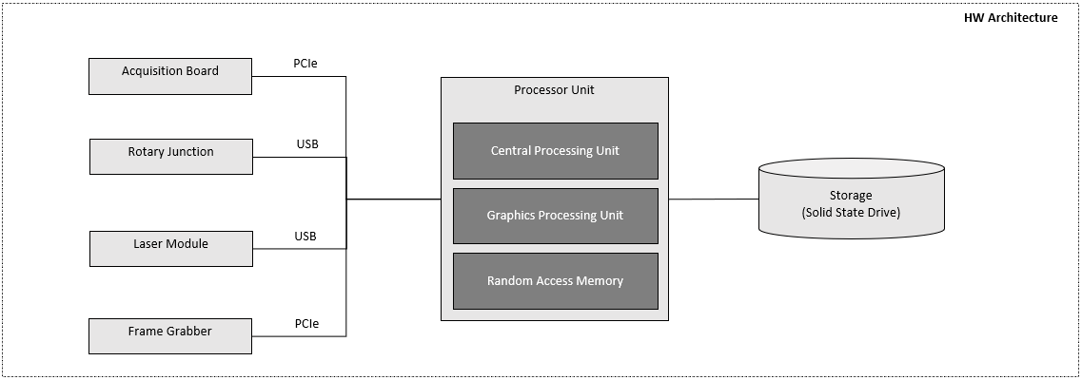

4.2 Software Architecture
Provide an overview of the software components, including:
- Operating system and firmware details
- Application software modules
- Software security controls and enforcement mechanisms
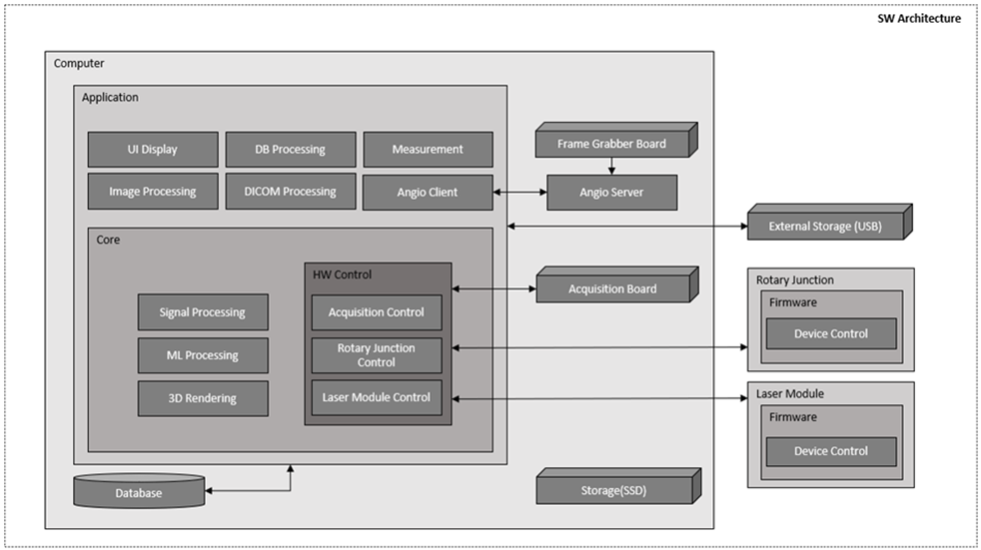

4.3 Network Architecture
Describe how the device connects to other systems and networks, including:
- Communication protocols and encryption standards
- Firewall and intrusion detection mechanisms
- Secure data transmission paths
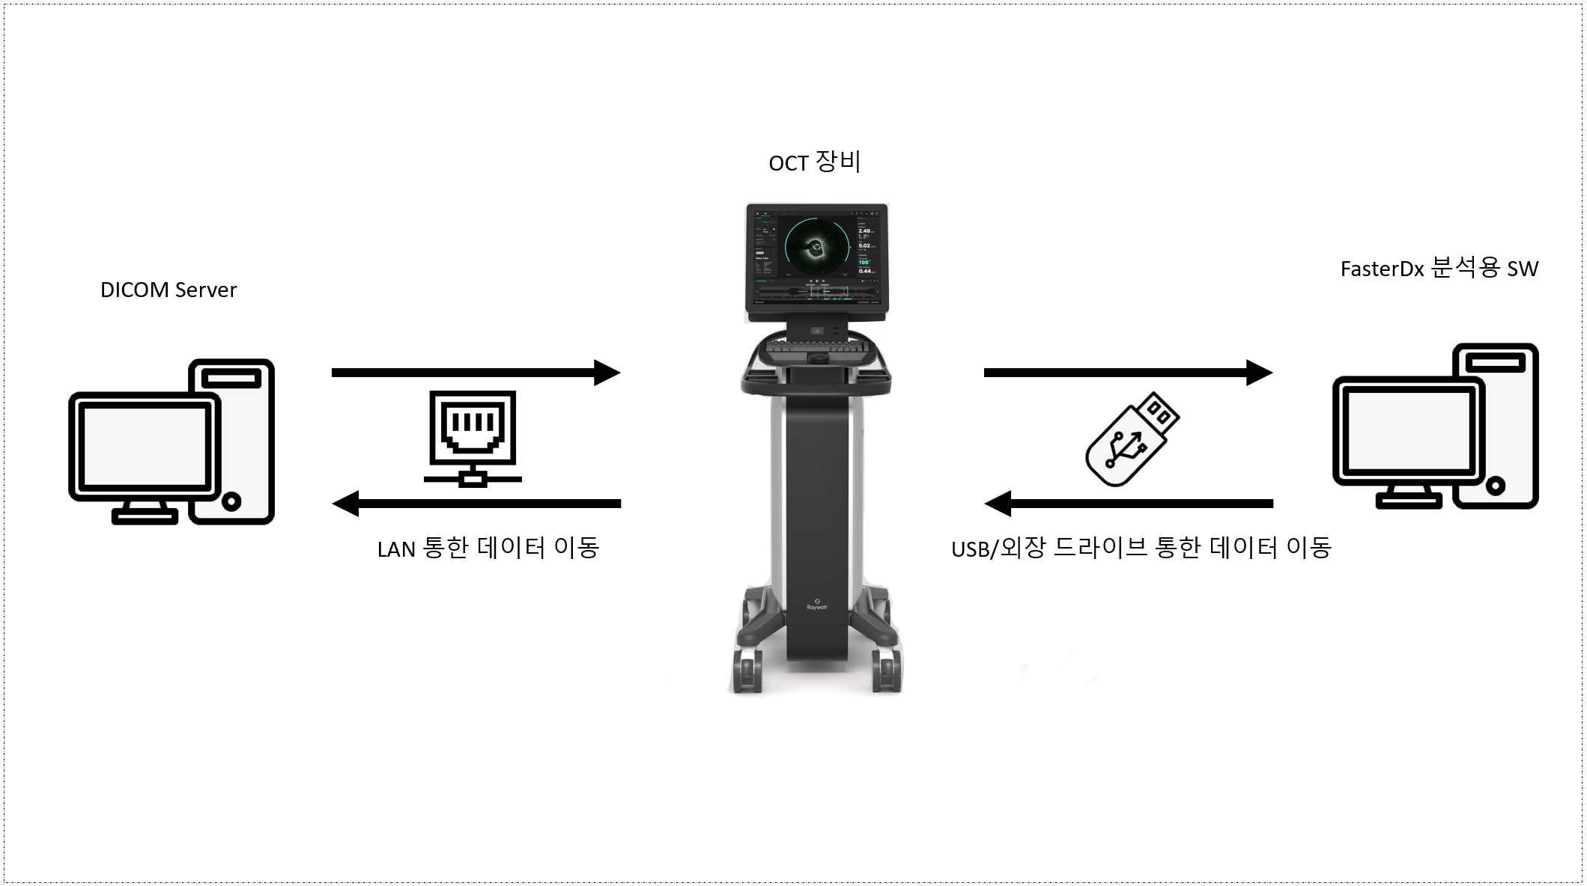
DICOM Server 와 LAN을 통한 연결은 TLS 1.3 사용

4.4 Data Flow Architecture
Illustrate how data flows between different components of the device system, including:
- Data input and output points
- Data storage and retrieval mechanisms
- Data integrity and encryption methods
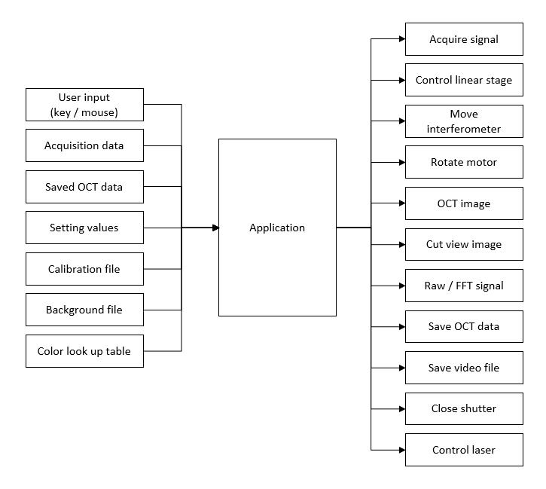

- Security Mechanisms and Controls
Describe the security mechanisms used to protect the device architecture, including:
- Access control and authentication mechanisms
- Secure boot and firmware integrity verification
- Logging and monitoring systems for anomaly detection
Windows 인증 사용
Windows AppLocker 를 사용해서 화이트리스트 실행 정책 적용 (비인가 소프트웨어 실행 방지)
Secure Boot 활성화 (부팅 시 악성코드 주입 방지)
Windows Defender 사용

- Documentation
Provide documentation practices for maintaining architecture diagrams and security design records.

